Works done

1. Added “Create alert” header menu.

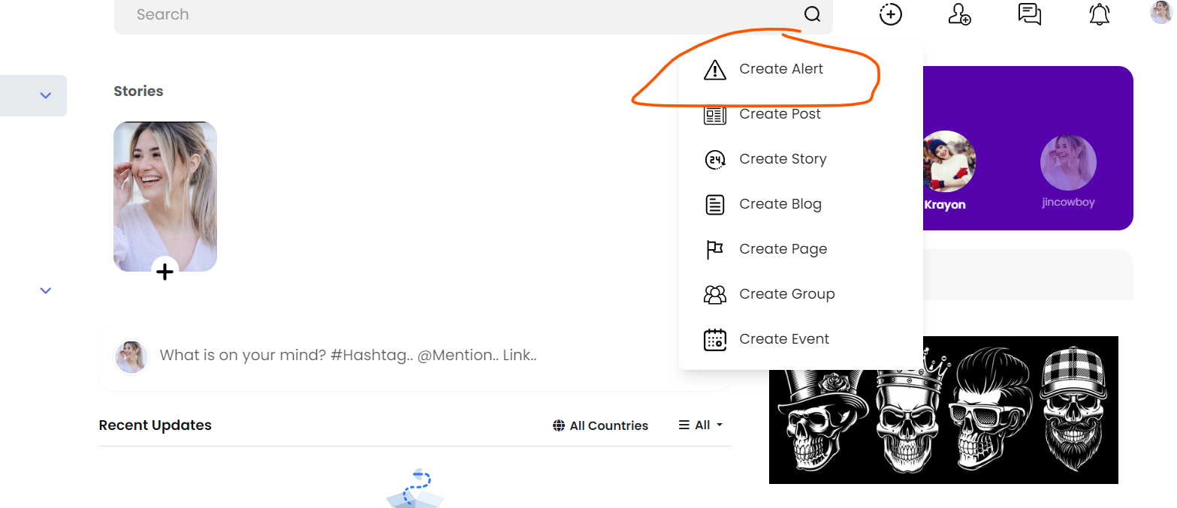

* Added a new SVG image file for icon “warning” 

1. Created a modal named “Create Alert”

Added a new SVG icon for “trash” 

1. Created 2 database tables named “alerts” “alerts_media”, it works for saving alerts data.

CREATE TABLE `alerts` (

`alert_id` int(10) UNSIGNED NOT NULL,

`user_id` int(10) UNSIGNED NOT NULL,

`time` datetime NOT NULL

) ENGINE=InnoDB DEFAULT CHARSET=utf8mb4 COLLATE=utf8mb4_general_ci ROW_FORMAT=DYNAMIC;

--

ALTER TABLE `alerts`

ADD PRIMARY KEY (`alert_id`),

ADD KEY `user_id` (`user_id`);

CREATE TABLE `alerts_media` (

`media_id` int(10) UNSIGNED NOT NULL,

`alert_id` int(10) UNSIGNED NOT NULL,

`source` varchar(256) NOT NULL,

`is_cover` enum('0','1') NOT NULL DEFAULT '1',

`alert` text NOT NULL,

`color` text NOT NULL,

`title` text NOT NULL,

`link` text NOT NULL,

`time` datetime NOT NULL

) ENGINE=InnoDB DEFAULT CHARSET=utf8mb4 COLLATE=utf8mb4_general_ci ROW_FORMAT=DYNAMIC;

-- Indexes for table `alerts_media`

--

ALTER TABLE `alerts_media`

ADD PRIMARY KEY (`media_id`),

ADD KEY `alert_id` (`alert_id`);

--

ALTER TABLE `alerts_media`

MODIFY `media_id` int(10) UNSIGNED NOT NULL AUTO_INCREMENT;

COMMIT;

1. Created Backend API for handling CRUD of alert data

Includes/posts/alert.php

1. Created frontend javascript api for integration with backend API.
2. Updated some permission tables.